[**https://miro.com/app/board/uXjVNm-t2zk=/**](https://miro.com/app/board/uXjVNm-t2zk=/)

Knight

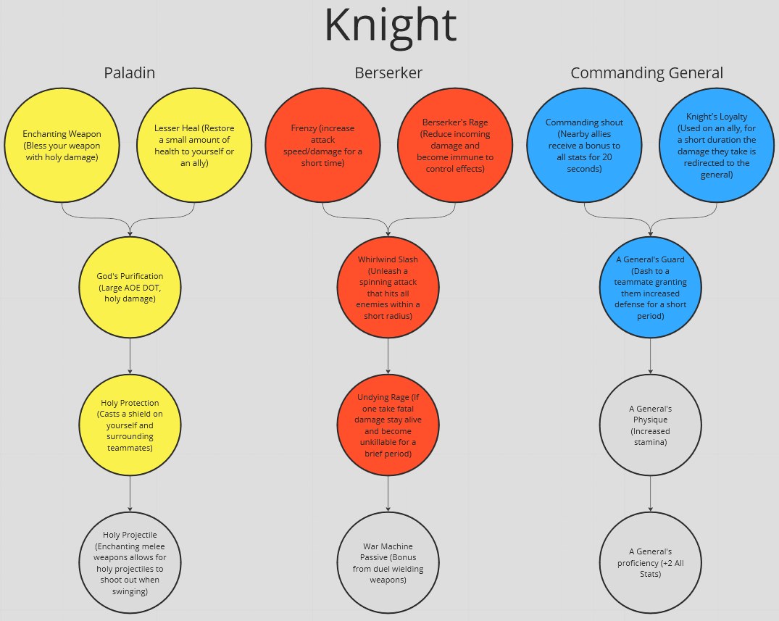

FOR DEMO, DO NOT INCLUDE PALADIN

AOE -> (Area of Effect)

DOT -> (Damage over time)

Colored Background -> (Active Skill)

Gray Background -> (Passive Skill)

**NEW CLASSES:**

Wizard

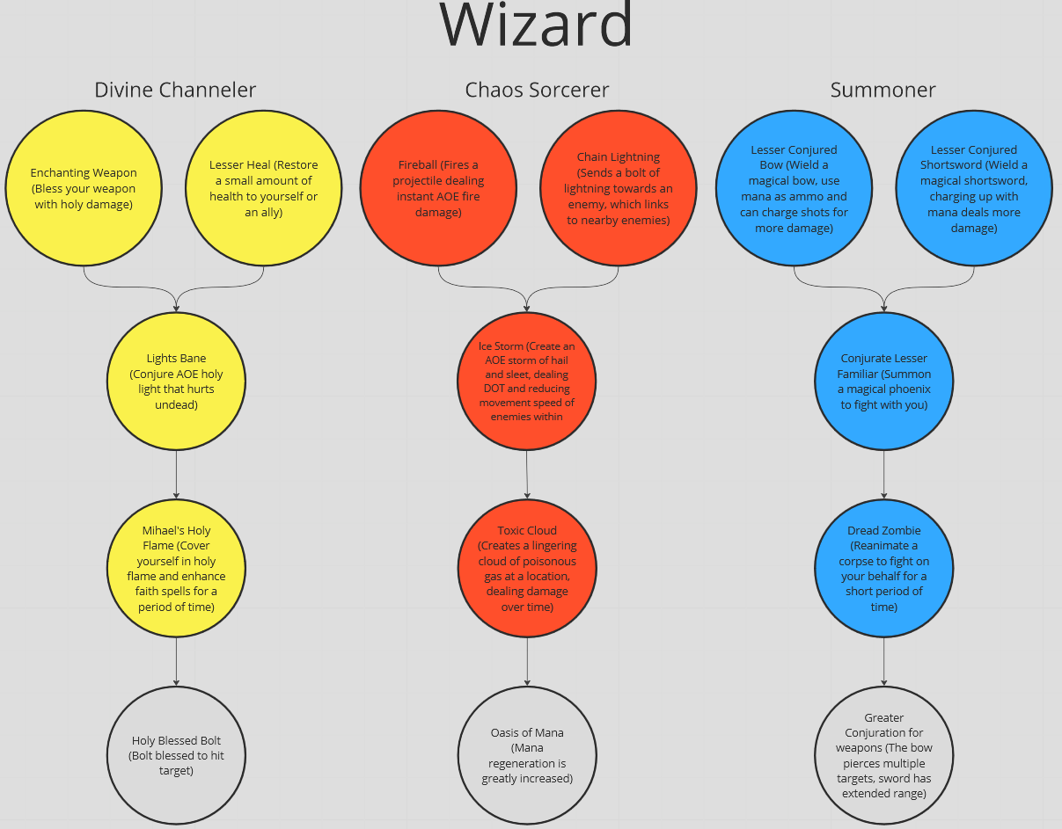

FOR DEMO, DO NOT INCLUDE SUMMONER

AOE -> (Area of Effect)

DOT -> (Damage over time)

Colored Background -> (Active Skill)

Gray Background -> (Passive Skill)

**NEW CLASSES:**

Ranger

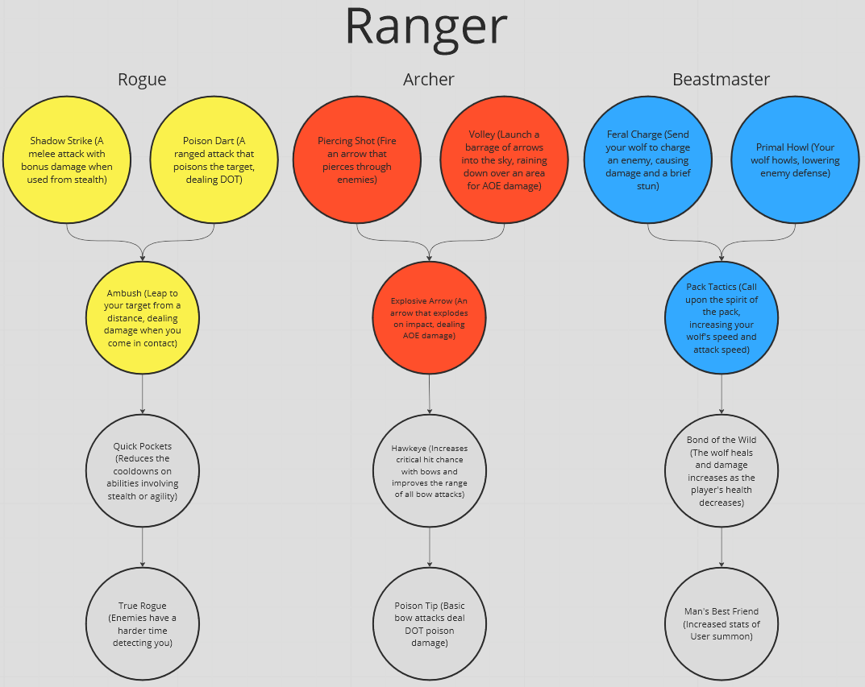

FOR DEMO, DO NOT INCLUDE BEASTMASTER

AOE -> (Area of Effect)

DOT -> (Damage over time)

Colored Background -> (Active Skill)

Gray Background -> (Passive Skill)

**NEW CLASSES:**

Assassin

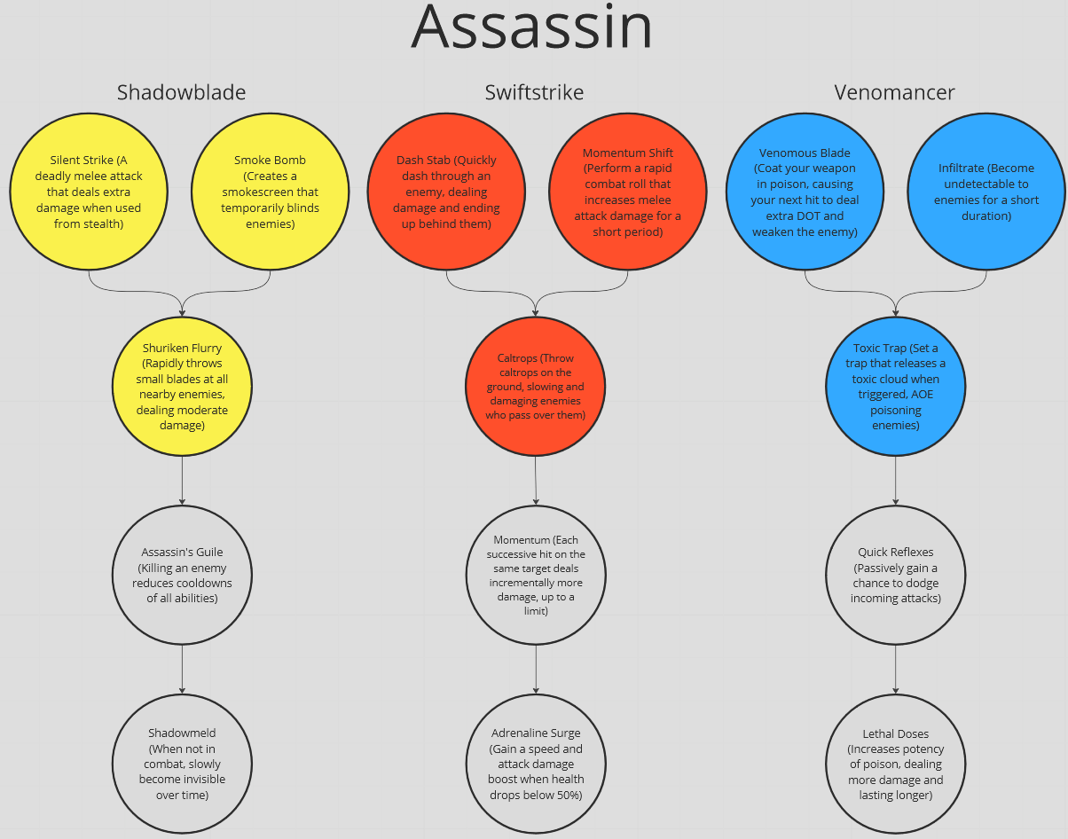

FOR DEMO, DO NOT INCLUDE SWIFTSTRIKE

AOE -> (Area of Effect)

DOT -> (Damage over time)

Colored Background -> (Active Skill)

Gray Background -> (Passive Skill)